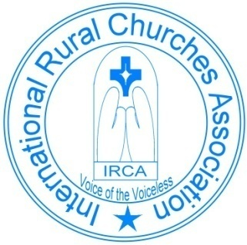
International Rural Churches Association
Voice to the Voiceless
IRCA-Oceania Questionnaire 2020

Hello from the IRCA Oceania Leadership Group.
We are now well past the dates on which this year’s IRCA-Oceania conference was to be held, but we still wanted to make contact with those of you who had expressed and interest in attending the conference or have been part of previous IRCA conferences, and as many rural church people in our region of Oceania.
The conference agenda was to include the future direction of IRCA Oceania and how this network could best support you/each other in ministry in rural communities. The theme for the 2020 conference was “Bringing Hope in Challenging Times” a theme made even more relevant given the unexpected changes and challenges that COVID-19 has brought to all of us this year. There will be stories of hope, as well as stories of pain, from this year’s ongoing experience.
In the light of this we want to invite you to share with us some of your stories from 2020. We would also love to hear any of your ideas about how you think IRCA might best support you in your rural context. Below are some questions that we thought might help to get you started. Respond to as few or as many as you wish.

What is happening for you and your churches in your area at this time?

What are the challenges?

What are you missing most because of the restrictions?

How are you doing church? Are you gathering? Holding church services?

What has influenced how have you adapted?

To sing or not to sing, what are you doing if you cannot sing at the moment?

How are you coping with death and grief in your community?

How are you managing transitions? Are changes in leadership still happening?

Are there plans for the future that your church community has had to put on hold?

How do you keep moving forward at this time?

What impacts on the rural community have you noticed and how are you responding to these?

How might we support each other as rural churches at this time?

How would you answer this big question: Where is Hope in this time of trial?

What is the likelihood of you being available and keen to attend an IRCA Oceania conference in August 2021? Yes / Maybe / No
(name and contact email)………………………………………………………………………..

We would love to hear from you about your thoughts and experiences this year. All responses will help us be of value to one another as the rural churches linked together as IRCA-Oceania. No deadline – just whenever you can.
May God bless you all with Hope in these extraordinary times.
IRCA Oceania Leadership Group
Katrina Gaydon, Stephanie Clay, Angela Dutton, Graeme Learsch, and Robyn McPhail
Please email responses to: irca.oceania@gmail.com

